**ASSIGNMENT 24.6**

* Using database:-

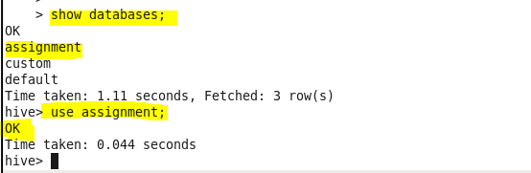

* Dataset:-

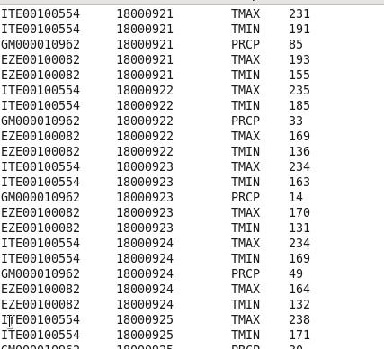

* **Write a hive query to find the minimum temperature observed in a given weather station in a particular year:-**

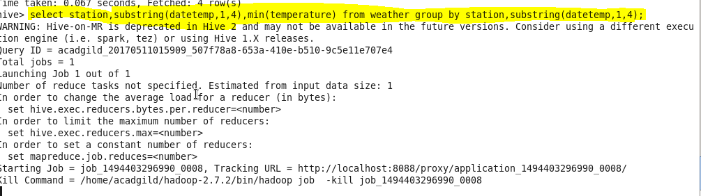

**Output:-**

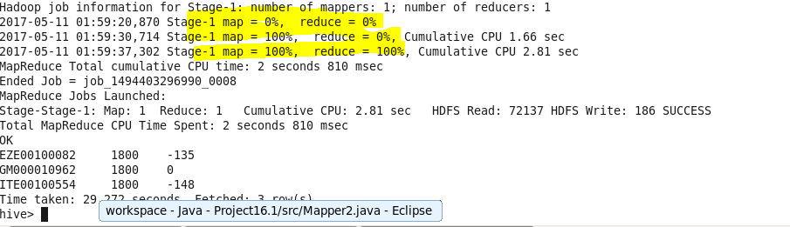

* **Write a hive query to find the maximum temperature observed in a given weather station in a particular year:-**

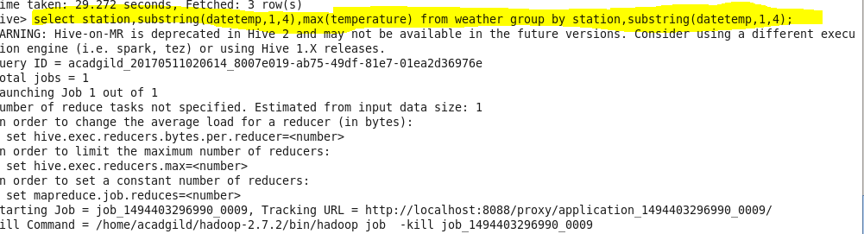

**Output:**

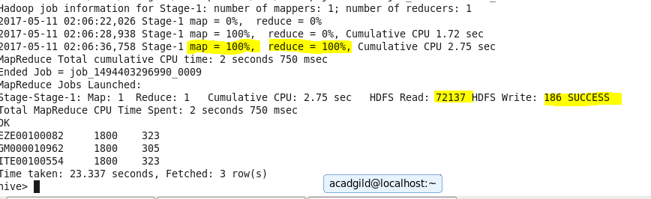

* **Write a hive query to find the number of readings given by each weather station according to the dataset?**

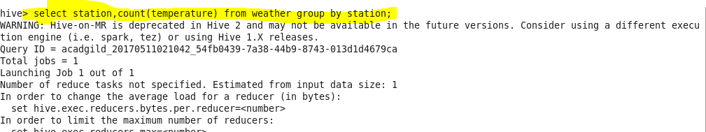

**Output:-**

